Defect Detective

Understanding Lateral Access Points

This installment focuses on the proper use of Lateral Access Points.

It is important to use the correct Access Point code when starting and ending Lateral Inspections.

The Access Point codes are the same as PACP with these additions:

- Access Point Backflow Preventer (ABP) – A valve used to prevent sewage from 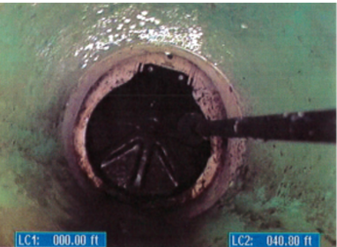 backing up into the lateral upstream of the valve
- Access Point Lateral Trap (ALT) – A device, such as a house trap, used to keep 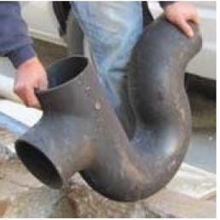waste and odors flowing away from the property, typically located at the ROW or house foundation
- Access Point Mainline (AML) – The point at which the lateral sewer connects with the 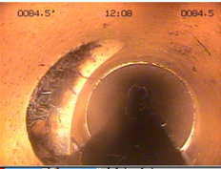 mainline sewer. This can occur in the mainline pipe or in a manhole
- Access Point Roof Vent (ARV) – Extension of lateral pipes that allow sewer gases to 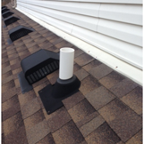 escape conveniently to the roof top, and prevent the water in toilets to be drawn out
- Access Point Wye (AW) - A side connection that has been built into the lateral sewer 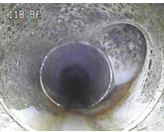 either using a pre-formed fitting or by breaking into the side of the lateral and installing a side saddle connection
- Access Point Double Wye (AWD) – Two side connections either using a pre-formed 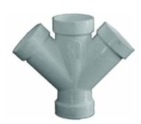 fitting or by breaking into the side of the lateral and installing two side connections at the same location
- Other (AZ) – Other type of access point not described above

Modifiers for Clean Outs are the same as for PACP with the addition of:

Saddle (ACOS) – A saddle installed on the lateral sewer to install a vertical riser from the saddle to the cleanout cap fitting

Testing your Lateral Access Point Skills
Referring to photograph A
Which Access Point is this?
Referring to Photograph B
Which Access Point is this?
Which Access Point is used if starting Inspection of a side connection in a lateral?
  - Access Mainline
  - Access Wye
  - Access Backflow Preventer
  - Access Roof Vent
If there is a Clean Out inside the house, what Access Point code is used?

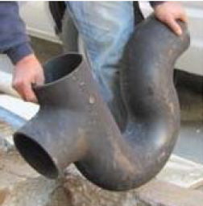 A

B

Answers:
- The Access Point pictured is an Access Lateral Trap (ALT).

- The Access point is Access Double Wye (AWD).

- The Access Point is Access Wye (AW).

- The code is Access Clean-out House (ACOH).

