Defect Detective

Understanding Deformed Flexible

This installment focuses on the proper use of the Deformed Flexible Code.

It is important to know the type of material that the pipe is made of, to determine if it is flexible, designed to deform before breaking, or rigid in construction.

The codes are further described using a Modifier as follows:

  - A Bulging Round (BR), where one or more rounded projections protrude into the pipe.
  - A Bulging Inverse Curvature (BI), where an inward bulge is sharp crested taking on the shape of a heart point or shark fin.
  - Creasing (C), where an outward folding of pipe wall in the longitudinal direction creates a crease in the wall of the pipe.
  - Elliptical (E), where the round pipe is compressed into an elliptical or oval shape.

There may not be any other signs of Structural defects (Cracks, Fractures) visible. When coding, one or two clock positions are required, depending on the size of the Bulge. If other Structural defects are present, they should be coded along with the deformed code as they are a sign of more significant structural distress. All other codes, O&M, Construction and Miscellaneous should also be coded.

Testing your Deformed Flexible skills
Referring to photograph A
Which Modifier would be used to describe this defect?
Referring to Photograph B
Which Modifier would be used to describe this defect?
Which of the following pipe materials are flexible?
  - Ductile Iron
  - Concrete
  - HDPE
  - VCP
If there is a fracture, along with deformation in PVC pipe, should it also be coded?

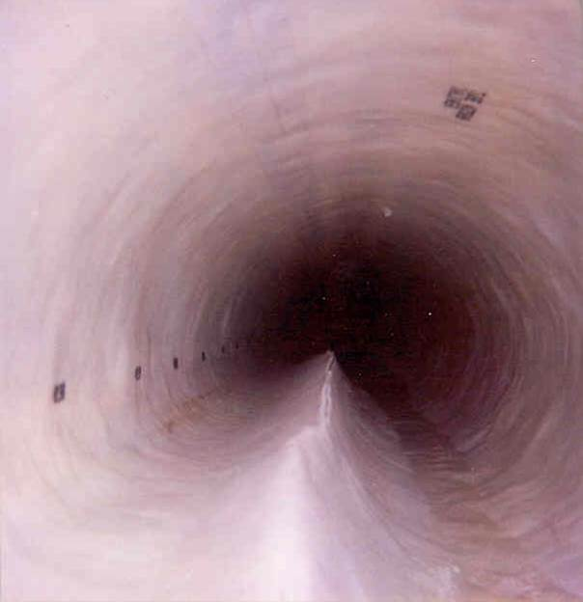 A

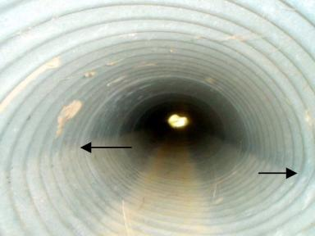 B

Answers:
- The Modifier used for the defect depicted in picture A is Inverse Curvature. Notice the sharp fin like shape of the Bulge.

- The Modifier used is Creasing. The arrows point to the creases in the pipe wall.

- The Flexible Pipe Materials are Ductile Iron and HDPE. Concrete and VCP (Vitrified Clay Pipe) are both Rigid Pipe Materials.

- Yes, Defects, in Flexible Pipe Materials, should be coded along with the Deformation Code.

